- Open a Power BI report with sales data and apply a Visual Level Filter to a bar chart so that it only displays products with sales greater than 500 units.
ANSWERS:
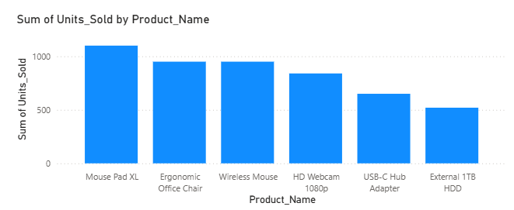

- Add a Page Level Filter to your dashboard that allows users to view only transactions from the city 'Ahmedabad' across all visuals on the current page.
ANSWERS:
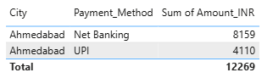

- Insert a Slicer for 'Payment Method' (e.g., UPI, Card, Cash) and sync this slicer across two pages in your Power BI report so that the selected payment method filters both pages.
ANSWERS:
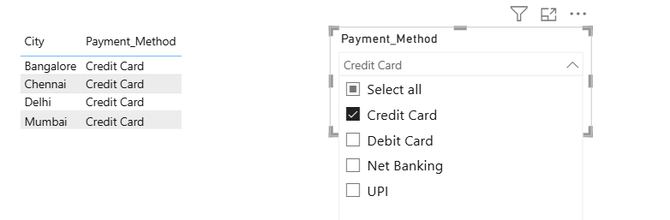

4.) Create a navigation button using Bookmarks and Buttons in Power BI that lets users jump from the 'Overview' page to a 'Top Customers' page and back, updating the view accordingly.

Hint: Use the 'Add Bookmark' and 'Action' features to set up the navigation.
ANSWERS:
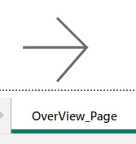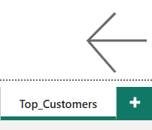

5.) Set up a Report Level Filter to show only data from the year 2023 throughout your entire Power BI report, regardless of the page or visual.
ANSWERS:

